Lincoln County GIS Map Viewer Documentation

Disclaimer:
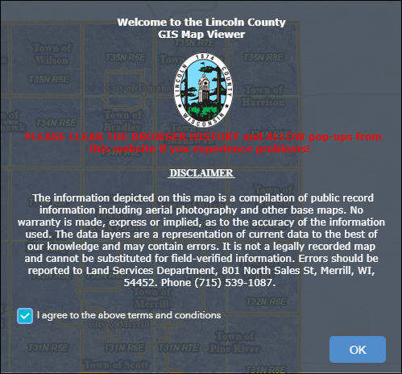
When you first open the GIS Map Viewer you will be prompted to read an introduction screen that outlines the purpose of the viewer and the data it is publishing. Click “Agree” to open the application.

Tax Data Disclaimer: The tax information is from the latest tax bill and may not be consistent with the parcel as it exists today. Clicking on the links to the Property Record System and Property Report at the bottom of the search results window will provide more information on parcels.

Opening Page:
This is a snapshot of the opening screen. The main tools are located along the top right of the map. Other information such as zoom tools, a home button, location, full screen, and previous/next extent are located on the left side of the page near the top. The “Search Information” tool opens automatically

Tools
Address
Search
Map Navigation Tools
Search Options and Results Window

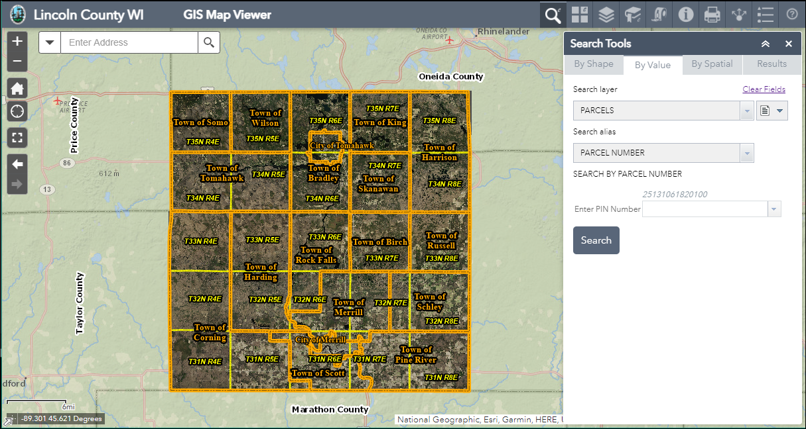
Longitude and Latitude

Tools Overview:

This is a quick overview of the tools. There are detailed descriptions found throughout the remainder of this document.

Search Tool: Clicking on this button will open the tools that allow you to search for parcels, streets, and waterbodies.
Basemap Gallery: Clicking on this button will open a window which displays the basemap gallery. You can choose a different basemap or layer and transition between two basemaps.
Map Layers: Clicking on this button will open a window showing all the map layers available on the website. Use it to turn layers on or off. Expand the layers list to view additional layers, create a legend, or make layers transparent.
Bookmarks: Clicking on this button will open a list of stored bookmarks. Users can create additional bookmarks or delete existing ones.
Draw and Measure: Clicking on this button will open a tool used to measure distance and area on the map and draw shapes.
Identify Tool: Clicking on this button will open a tool that allows you to discover data about one or more layers on the map in a single location. This is a powerful data layers drilling tool.
Print Map: Clicking on this button will open a map printing tool enabling the user to print map documents in different sizes and layouts.
Legend: Clicking on this button will open a legend of all currently selected layers and features that are viewable on the map.
Share: Clicking on this button will open a tool that will allow you to share your current web view and web environment with others.
Site Help: Clicking on this button gives you the link to the site usage document for the GIS Map Viewer, as well as contact information for the Lincoln County Land Services Department.

Detailed Tools Overview:

Map Navigation Tools:
Zoom
The navigation tools have the look and feel of
those used by common Internet mapping sites.
Return to Full View

Find My Location

Enter Full Screen View

Return to Previous/Next Extent

Search Information: This window opens automatically every time you open the website. You can search for tax parcels, streets, lakes, and streams.

Search Information by Value:
This pull down will allow the user to create a new selection, add to a selection set, or remove features from the current selection.

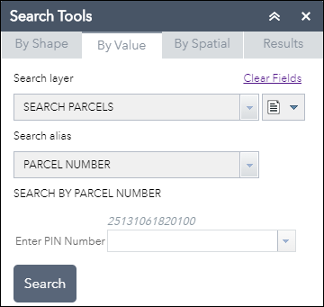
The final step is clicking search. The map will automatically zoom to the feature when search is clicked.
Select the layer you want to search.
Select type of search- such as PIN, Owner Name, Address, or PLSS. Options will change with layers.
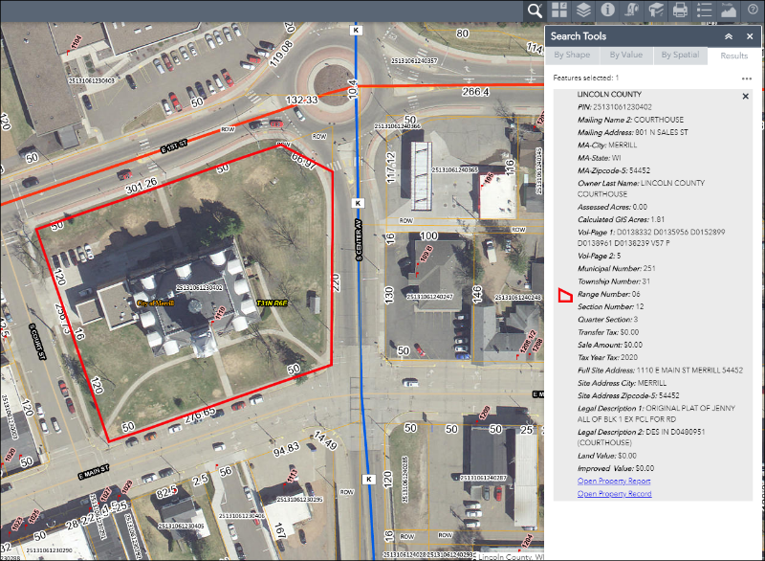
For this example, all you would need to do is type in the Parcel Number and click “Search.” The map will zoom to the selected parcel and information about the parcel will be displayed in the “Search Results” window on the right.

Other options for a value search for parcels are found in the “Search Alias” drop-down list:
Owner Name – Start by entering owner’s last name, and then first name below. A drop down list will be available to narrow results if needed.
Address –Start typing an address and a list of options will become available.
PLSS – Enter a Public Land Survey System Section, Township, and Range.

Search Results:
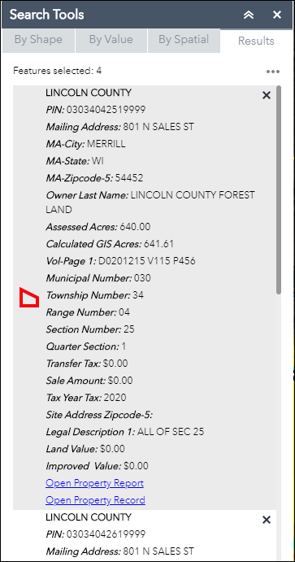
At the bottom of the Search Information window is a link to the Tax Report and Tax Record for each selected parcel. Clicking the links (in blue) will take you to the Real Property Lister website.
If your search returns multiple features, the number of features selected is shown near the top of the “Search Information” window. You can scroll through the data, view Stats, or Export to a CSV file. Stats include combined data such as calculated GIS acres, transfers tax, sale amount, and assessed acres.
When you export the data to a CSV (comma separated values) file, your computer’s browser settings determine how the file is handled.

TIP: Refer to appendix at the end of the document to learn how to import CSV files to Microsoft Excel.

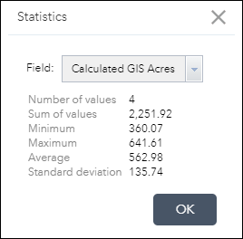
The Statistics option under the Results Menu works for all the numerical attribute fields, including calculated GIS acres, transfer tax, sale amount, improved value, assessed acres, tax year tax, and land value. Open the menu by selecting the ellipsis above the upper right edge of the Results window. Multiple parcels need to be selected for the Statistics tool to be available.

Use drop down to choose an option from the fields available for statistics.

Search Information by Shape:
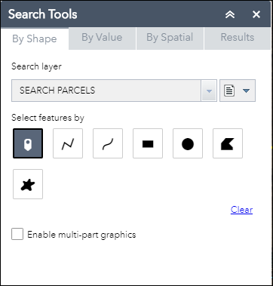
Another way to search for parcels, streets, lakes
and streams is by drawing a shape or selecting a
point on the map.
Once features are selected the results are displayed
Pick one of these graphics to select features off of the map.
in the “Search Information” window.

Clicking on “Enable multi-part graphics” lets you select multiple features at once.

Search Information by Spatial:
The spatial search tool allows you to buffer your current selection set to select additional features.
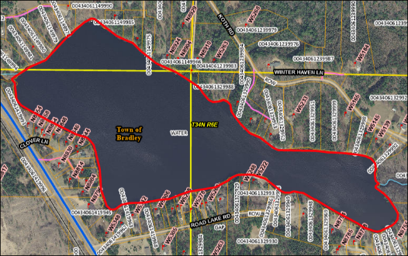
Here is an example of how the tool can be used: Road Lake was selected using a graphical search. Click on the “By Spatial” tab and set the search distance to 100 feet.
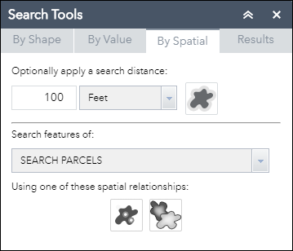

Click the “Apply Buffer” icon to finish STEP 1

In STEP 2 you may also choose to select parcels entirely contained, intersected by, or intersected by the envelope of the buffered area. For this example we chose parcels intersected by the buffer. There are 69 parcels are within 100 feet of Road Lake.

STEP 1 Result
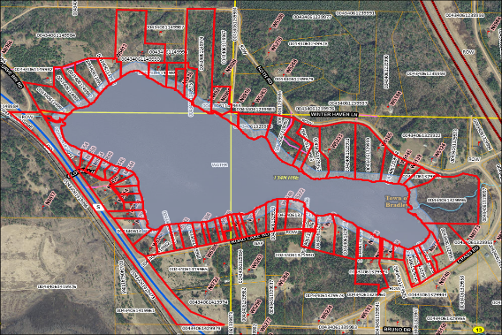
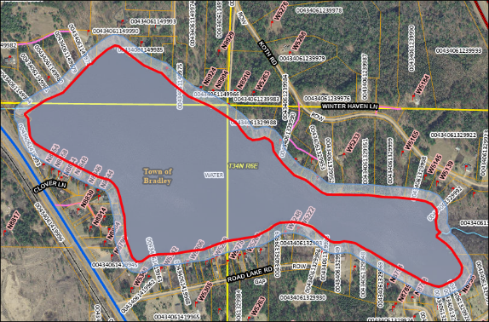

STEP 2 Result

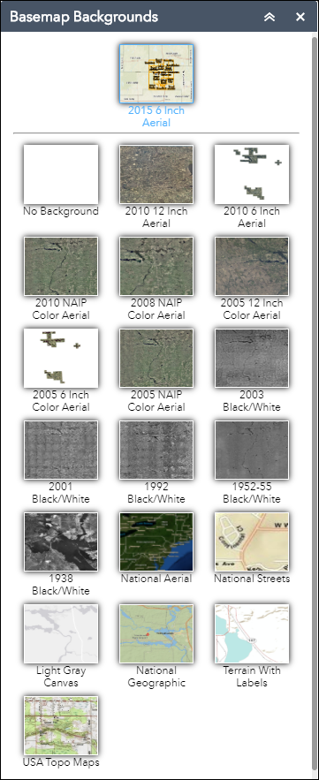
Enhanced Basemap Gallery: Clicking on this button will open a window where the user can pick a background map. There are different years of ortho imagery (aerial photos corrected for topography), a shaded relief map, a light gray basemap, or a blank background.

To change basemaps simply click on one. To transition between two basemaps, click on the green plus sign that appears on the top left corner of the basemap when you hover over it and it will be added to the top of the basemap window. A transition bar will appear to slide between the basemaps. Click red X to remove.

Layer List: Clicking on this button will open a window showing all available layers that can be turned on or off. Expand individual layers to view symbology. All data layers are grouped logically. The best way to learn about the available data is to expand each layer to discover what is there.

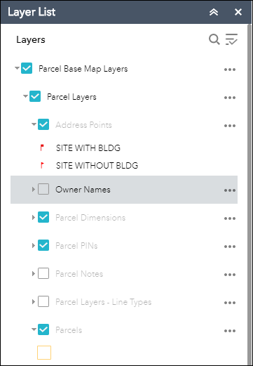

Use these arrows to expand layers.
This pull down will allow the user to turn all layers on or off or expand or collapse all layers.

Turn individual layers on and off by checking or unchecking these boxes.

Clicking on the ellipsis gives you more options on ways you can change how the map looks and works. Use these pull downs to zoom to a layer, adjust its transparency, set a visibility range, enable pop-ups, or change its drawing order.

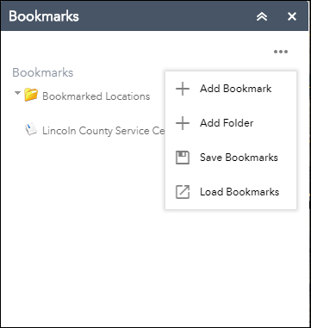
Bookmarks: Clicking on this button will
open the bookmarks tool. Users can create
Clicking on the ellipsis opens the drop down menu of tools.
bookmarks for specific locations or delete
existing ones. Bookmarks are an efficient way to
quickly return to a desired location or locations.

TIP: If your bookmarks are gone after you close

and reopen the website, make sure your Internet

settings allow the use of cookies from this website.

Draw and Measure: Clicking on this button will open a tool used to draw shapes and measure distance and area on the map.

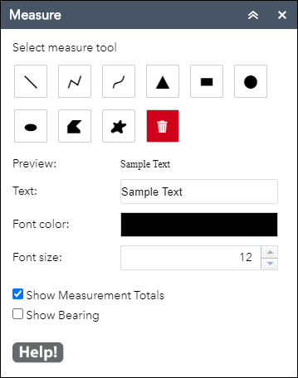
Start by selecting the type of drawing you want to add to your map.

The measurement will be shown on your drawn feature. You can change the color and size of the font to show better on the basemap.

Check these to show measurements totals and/or bearings. Bearings will show when you draw a feature using the Polyline tool or when you use vertexes to adjust drawn straight lines. The Polyline tool is the second measure tool shown above.

After your drawing is complete, you can select a line of the finished sketch and movable vertexes will appear to adjust the lines. The measurements will adjust as the lines move.

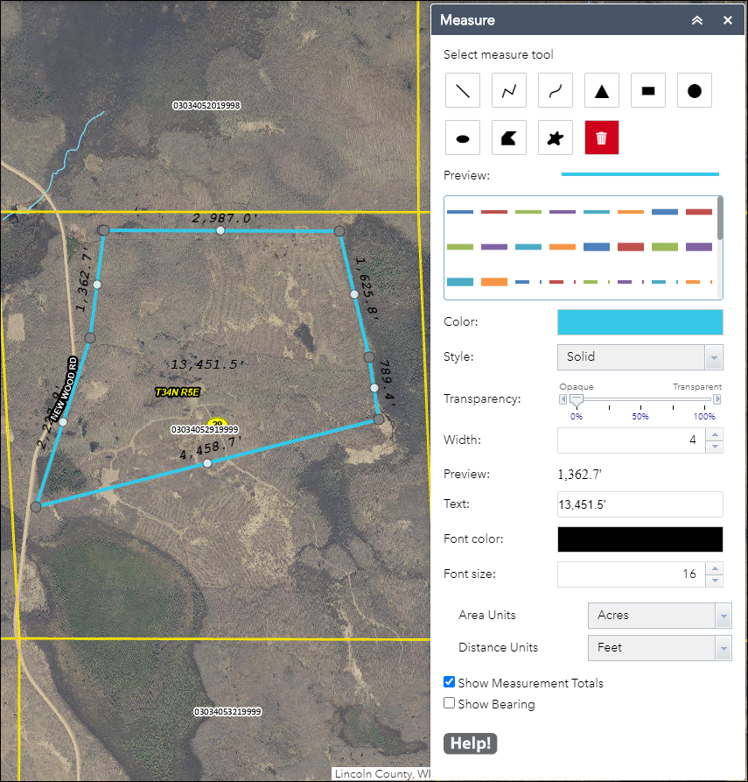

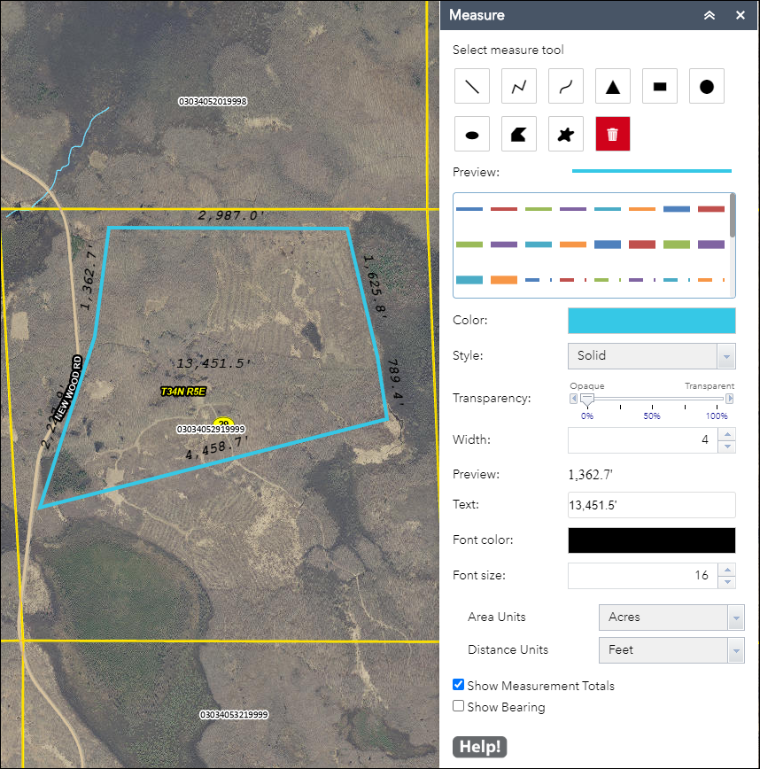

Identify Features Tool: Clicking on this button will open the Identify tool. You can discover data about one or more layers by drawing a shape or selecting on the map. Layers you may query include Parcels, Address Points, Roads, PLSS, Post Office Zip Codes, Subdivisions, CSMs, County and City Zoning, Flood Hazard Zones, School Districts, Wards, Supervisor Districts, and several others.

This drop down allows you to choose a single layer to identify from. The Identify tool will always default to all layers.

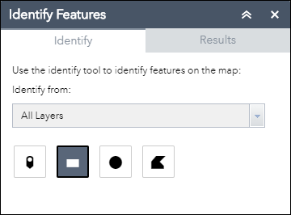

Pick one of these graphics to select features off of the map.

TIP: A layer does not have to be visible for the identify tool to work.

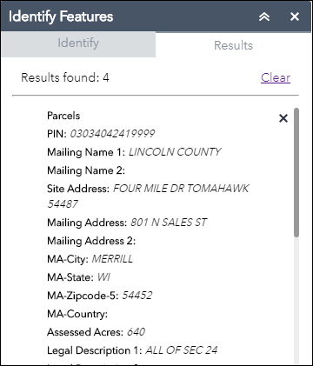

Print Map: Clicking on this button will open a map printing tool enabling the user to print map documents in different sizes and layouts. Users have the option to add a title, select the map’s layout and file format, and add the author’s name. In the Layout templates dropdown, the user can pick a page size and orientation. In the Formats dropdown, the user may choose to create a map in one of eight different file formats. When you click the “Print” button, a map document will be created and displayed within the print tool window. By clicking on the map file, the map will open in a new window in your browser. IF YOU DO NOT GET THE MAP, IT IS PROBABLY DUE TO YOUR POP-UP BLOCKER SETTINGS. The user can save and/or print the document. Print preview should be used to preview the document to make sure the landscape/portrait orientation is correct for your print settings.

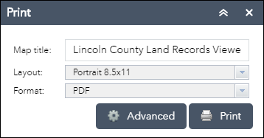

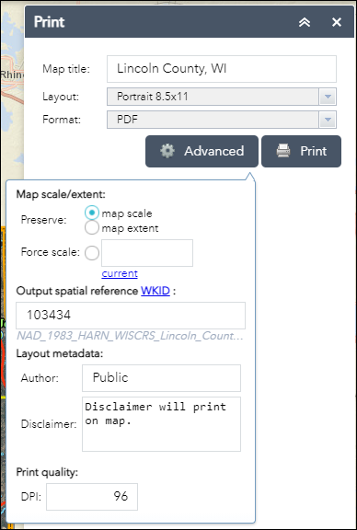

If your map printout does not look like you expected it to, experiment with the preserve map scale, map extent, or force scale options found in Advanced settings. Using the Portrait 8.5 x 11 Layout Template for this example, the map was saved twice. Below on the left is what you will get if “Preserve: map scale” is checked. Below on the right is the same map with “Preserve: map extent” checked.

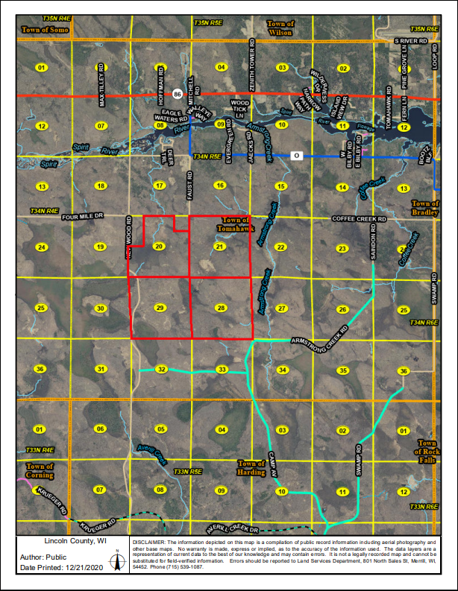
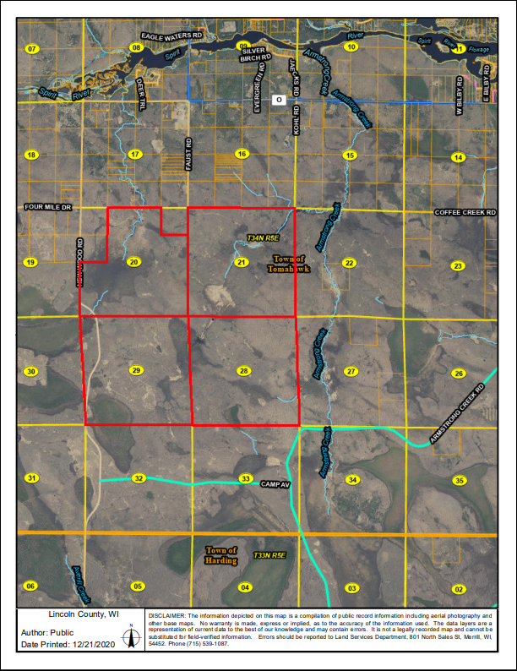

Share: Clicking on this button will open a tool that will allow you to share your current web view and web environment with others.

- Click the Share widget icon to open it.
- Copy the short link under Share a link to this app and paste it into your email, instant message, and so on. You can also use the provided buttons to post your app to your Facebook, Twitter, or Google accounts, or in an email.
- Optionally click Link Options to easily define URL parameters included in the short link. See Use URL parameters.
  - Check the option or check box to add a URL parameter from the following options. You can preview the URL change in the Link preview box.
      - Current map extent—This is used by default.
      - Click the map to define the center of the map with zoom level—A point icon shows under the option when it is checked. Click the icon and click where you want the map to center in the app. A point marker will be added on the map, and the URL in the link preview will be updated accordingly based on the map zoom level.
      - Click the map to define the center of the map with map scale—A point icon shows under the option when it is checked. Click the icon and click where you want the map to center in the app. A point marker will be added on the map, and the URL in the link preview will be updated accordingly based on the map scale.
      - Find the location or feature and zoom to it—Input a location in the box, such as Redlands, ca, 92373, or a feature in a searchable layer.
      - Query a feature and zoom to it—Choose a layer, a field, and a value from the menus to query a feature and zoom to it. Attribute values are sorted in ascending order. Type in the search box to select from a reduced list of relevant values.
      - Add a marker on the map—Click the point icon and click where you want to add a marker in the map. Fill in the WKID, Pop-up title, Symbol, and Label properties in each text box.
      - Overwrite default screen size of mobile layout—Input the screen size in pixels. By default, when either the height or width of a screen display is less than 600 pixels, the mobile layout automatically applies.
      - Set display language of the app—Choose a language from the drop-down menu.
      - Remember layers visibility—Respects the layers' visibility on the current map.

Caution:
If the map content has large amount of layers, remembering layer visibility could result in an overlong URL that may be failed to be interpreted by server. Share widget will try to shorten the URL by encoding layer ID using Hash algorithms if possible, but it will not guarantee a practicable URL. (Parameter showLayersEncoded= or hideLayersEncoded= will be used in URL if the layer id is encoded.)
You will see a warning message when the URL exceeds 2048 characters (as most servers have a limit of 2048 characters in URL when interpreting it). In this case, it is suggested to ignore visibility information.
- Click -> to return to the main panel. The short link should be updated to reflect the URL change made in the step above.
- Under Embed this app in a website, copy the HTML code and paste it into your website. If you want, click Embed Options to choose the size of your app to be embedded.

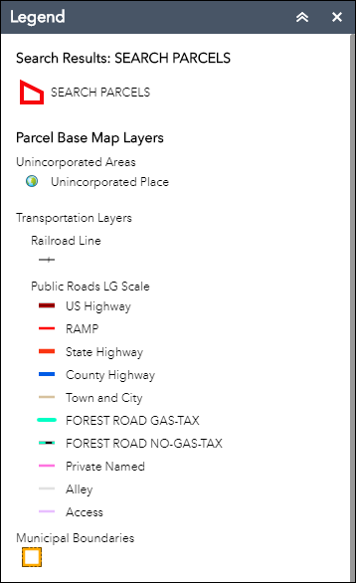
Legend: This tool opens up a map legend for the user to view. It shows all the currently selected layers and features that are viewable on the map. It is labeled cleanly.

Help - Contacts: Clicking on this button gives you the link to the Help document for the Lincoln County GIS Map Viewer. If you have further questions about using the website, or about the information you found on the website, there are also links to the Lincoln County Land Services Office. This is a link back to the http://maps.co.lincoln.wi.us/webapps/GISPortal/index.html portal page. Use it to discover the other maps, records, and links related to land records.

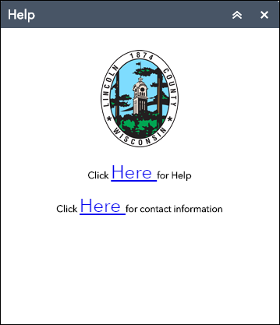

Appendix A
Transferring data from the mapping application to Microsoft Excel 2016

Data selected using the search tool can be exported to CSV file format, the following is instructions on how to import that file to Microsoft Excel.

To start this process use the search tool to select parcels of interest.

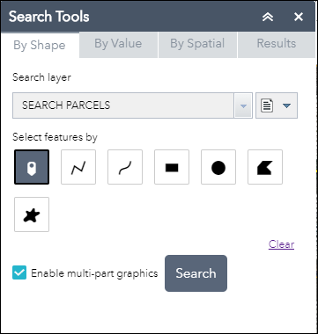

Results will automatically be displayed as shown.

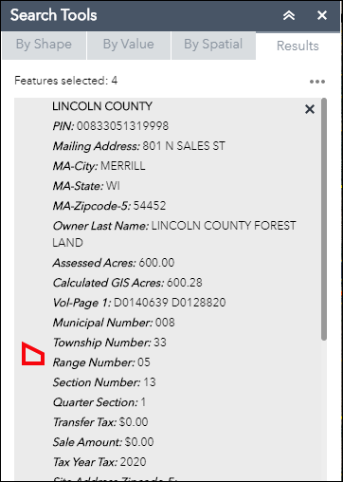

Click on the ellipsis in the upper right-hand corner and select the Export to CSV file option.

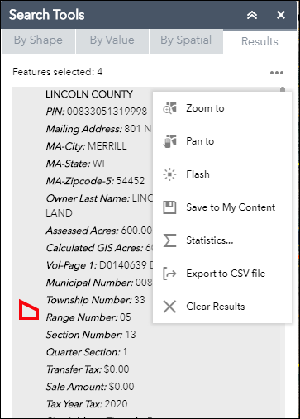

The CSV file will be downloaded to your computer.

Open Microsoft Excel and under the Data tab on the top of the screen select “From Text” which is in the “Get External Data” category.

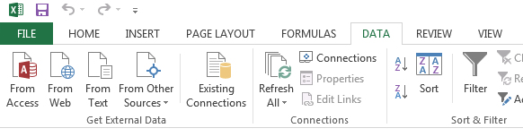

This option will then take you to a wizard with three steps that you need to follow as directed below.

Step 1: Find your downloaded file, select it, and click on import

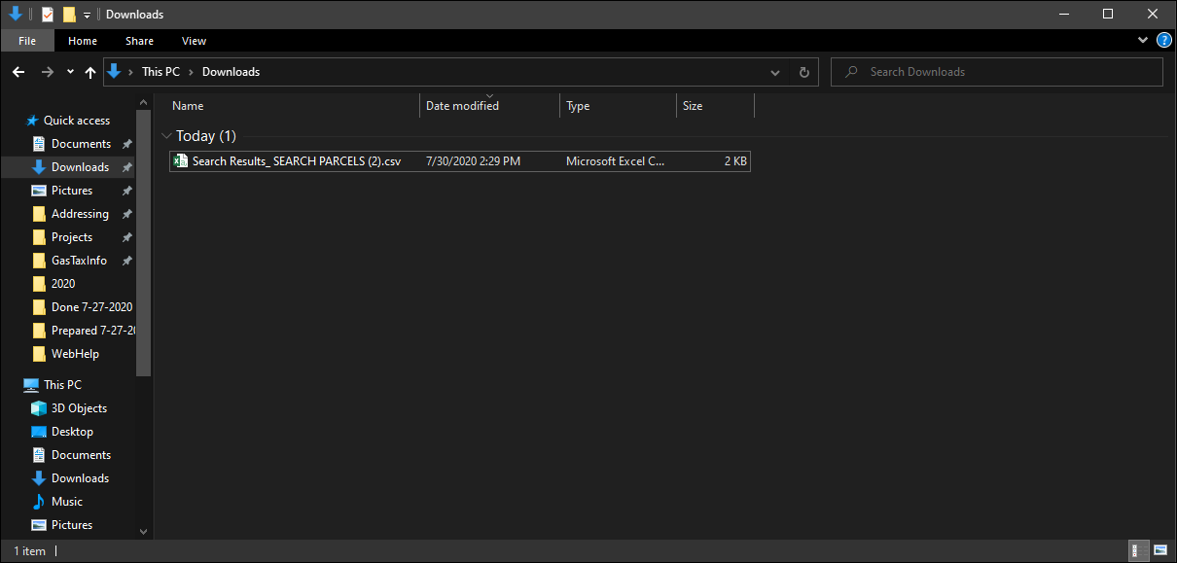

Step 2: Make sure all the options are as follows below, you will more than likely need to select “My data has headers”. Click Next.

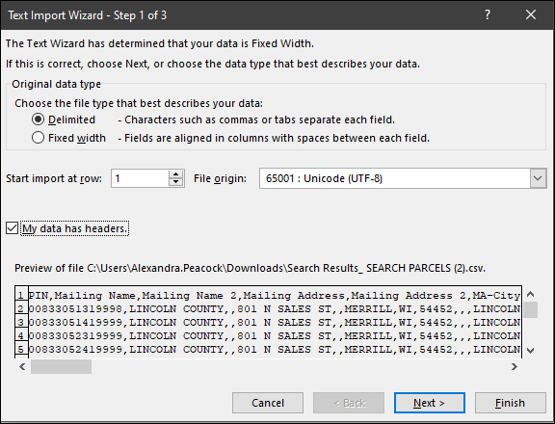

Step 3: On this screen select the “Comma” delimiter and deselect the “Tab” delimiter. Click Next

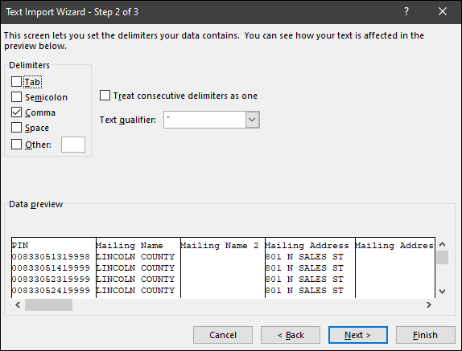

Step 4: All the Columns data format is set to “General” you must change the format of the PIN column.

Make sure the PIN column is selected (Highlighted in Black) and change the format to Text.

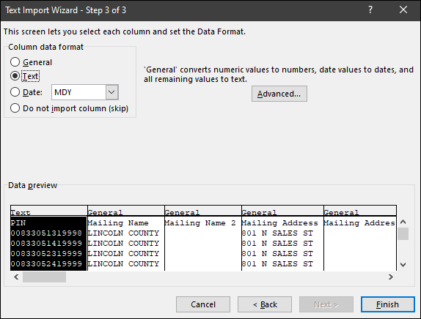

Click Finish and import your table into Excel. All the same data from the mapping application should be there.
